Desert Heartdwellers Phase Two
November 2nd, 2022

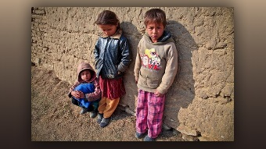
Dear Lord, please give us strength when we are weak, love when we feel forsaken, and the courage and Godly wisdom to go forth boldly and proclaim all that You have for us. Amen.

Dear Family, we continue to move forward with the vision the Lord has given us to complete His work in the desert. We have secured the land and are weeks away from finishing Phase One which is the installation of the power systems such as solar, water catchment, compost, electrical and propane.

We pray to be able to begin Phase Two which is the building of the desert end times refuge to serve the souls in this area, and with God’s miracle working power through us, help deliver these precious ones from all manner of demonic infestations, powerful, generational strongholds and deep rooted witchcraft. The Lord has told us there will be miracles, healing and deliverances, the likes we have never seen. All we need to do is to be willing to cooperate with Him and work in union with His graces.

Brothers John and Patrick have been working hard this past month implementing the first phase and we will soon be depleted of funds to begin building the desert refuge. We reach out to you dear family, to help us complete the Lord’s mission.

These forgotten ones live in the most deplorable conditions and our assignment is to share God’s love, His peace and bring them to His feet to experience His unending mercy and compassionate heart for them, so that their eternal destination will be Heaven, and not the fires of Hell.

We need your prayers, builders and support to release these souls from a lifetime of bondage. If the Lord puts on your heart to help, please donate on the link below.

https://www.gofundme.com/f/z9rege-desert-heartdwellers-phase-two?utm_source=customer&utm_medium=copy_link&utm_campaign=p_cf+share-flow-1

God bless you dear ones and may the light of Christ shine on all around you.

Brother John and Sister Jane

